**DATA STRUCTURE PRACTICAL 1:ARRAY ADT, DYNAMIC MEMORY ALLOCATION AND ARRAY REPRESENTATION**

**Name: Devvrat Miglani**

**Roll No:37**

1. C Program to Find Sum of Array Elements using Pointer.  The program should

dynamically allocate a piece of memory for that array and use a pointer to point to that

array memory as well as traverse that array using a pointer.

int *ptr = (int*) malloc (n * sizeof(int));

**Program:**

#include <stdio.h>

#include <stdlib.h>

int main(){

int* ptr;

int n,i,sum=0;

printf("Enter number of elements:");

scanf("%d",&n);

printf("Entered number of elements : %d\n", n);

ptr = (int*)malloc(n * sizeof(int));

printf("enter the elements:\n");

for(i=0;i<n;i++)

{

scanf("%d",&ptr[i]);

}

for(i=0;i<n;i++)

{

sum = sum + *(ptr + i);

}

printf("sum of array is : %d\n",sum);

}

**Output:**

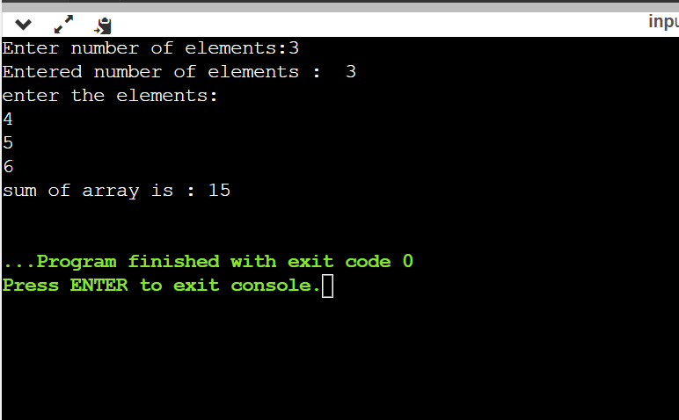

1. To study an Array ADT and to implement various operations on Matrix(two

dimensional array) [include display array in row major and column form, finding

transpose, matrix addition and multiplication]

a. Write a C program to implement 2D array and display array in Row-Major-

Order and Column-Major-Order.

b. Write a C program to input two 2D arrays and display their sum, and

multiplication.

c. Display the transpose of the matrix

**Program:**

#include <stdio.h>

#include <stdlib.h>

int main()

{

int n,i,j,m;

printf("enter the dimension of array :\n");

scanf("%d %d",&m,&n);

int* a = (int *)malloc(m * n * sizeof(int));

printf("enter the array elements : \n");

for(i=0;i<m*n;i++){

scanf("%d",&a[i]);

}

printf("colomn major order : \n");

for(i=0;i<m*n;i++){

printf(" %d ",a[i]);

}

printf("\n ");

printf("row major order :\n");

for (j = 0; j < n; j++){

for (i = 0; i < m; i++) {

printf(" %d ", a[i * n + j]);

}

}

printf("/n");

printf("transpose of the matrix :\n");

for (i = 0; i < m; i++) {

for (j = 0; j < n; j++){

printf("%d ",a[j * n + i]);}

printf("\n");

}

printf("\n");

int* b = (int *)malloc(m * n * sizeof(int));

printf("enter the 2 array elements : \n");

for(i=0;i<m*n;i++){

scanf("%d",&b[i]);

}

printf("addition of 2 matrix is : \n");

for (i = 0; i < m; i++) {

for (j = 0; j < n; j++){

printf("%d ", b[i * n + j]+a[i * n + j]);}

printf("\n");

}

printf("multiplication of matrix is : \n");

for (i = 0; i < m; i++) {

for (j = 0; j < n; j++)

printf("%d ", b[i * n + j]*a[j * n + i]+ b[j * m + i]*a[i * m + j]);

printf("\n");

}

return 0;

}

**Output:**

